Division
Foundation Stage 1:
- 30 – 50 months - Separate a group of three or four objects in different ways, beginning to recognise the total is still the same.

Concrete | Pictorial | Abstract
Separate groups of objects in different ways – begin to introduce half/double if pupils are ready.

Foundation Stage 2 Objectives:
- 40 – 60 months - They solve problems, including doubling, halving and sharing.
Concrete | Pictorial | Abstract
Practically halving everyday objects – the halves being the same size. Begin with halving play dough and other items that could be cut, then use hoops /halving mats etc. to separate items.  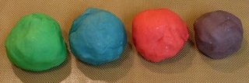 | Halving images  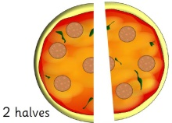  Finding the other half of everyday shapes to match them e.g. cups, beans | Half of … is … (adult written)
Doubling everyday items e.g. compare bears, counters etc. | Doubling e.g. the spots on the ladybird. | Double 1 is 2…(adult written)  1 + 1 = 2  2 + 2 = 4
Year 1 Objectives:
- solve one-step problems involving division, by calculating the answer using concrete objects, pictorial representations and arrays with the support of the teacher.
Concrete | Pictorial | Abstract
Find half of even numbers up to 12, using fingers and objects. | 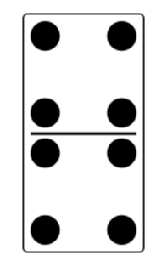 | Half of 8 is 4  8 ÷ 2 = 4
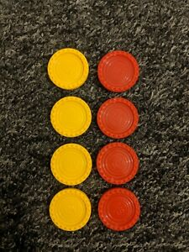  Develop finding half of numnbers before moving onto finding quarters  whole  1/2s  1/4s | Circle half of the apples.  Circle a quarter of the apples. | Half of 8 is 4.  8 ÷ 2 = 4  One quarter of 8 is 2  8÷ 4 = 2
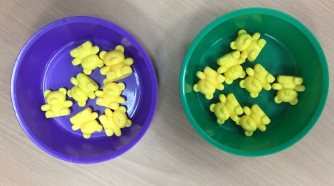  Begin to find half of a quantity using sharing e.g. half of 14 cubes by sharing one at a tie into two sorting dishes. | Share equally between 2. | Half of 14 is 7  14 shared between 2 is 7.
Grouping:  Use concrete and visual arrays/sets of objects to find answers to e.g. 15 girls play a game in teams of 5. How many groups are there?  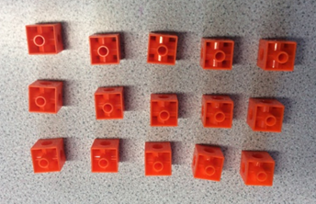 | 5  5  5  5 5 5 | Total number of objects ÷ number in each group = number of groups.  There are 3 groups of 5 in 15, so  15 ÷ 5 = 3
Year 2 Objectives:
Pupils should be taught to:
- recall and use multiplication and division facts for the 2, 5 and 10 multiplication tables, including recognising odd and even numbers
- calculate mathematical statements for division within the multiplication tables and write them using the division (÷) and equals (=) signs
- show that multiplication is commutative but division is not
- solve problems involving division, using materials, arrays, repeated addition, mental methods, and multiplication and division facts, including problems in contexts.

Concrete | Pictorial | Abstract
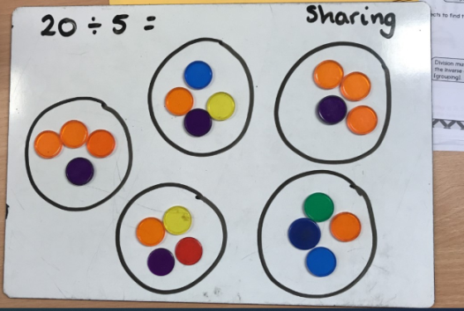  Continue to explore division as sharing  20 shared between 5 groups gives us 4 in each group.  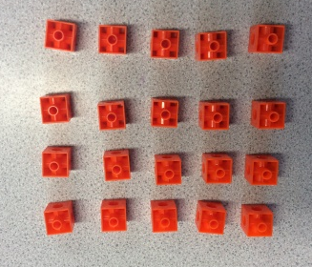 | 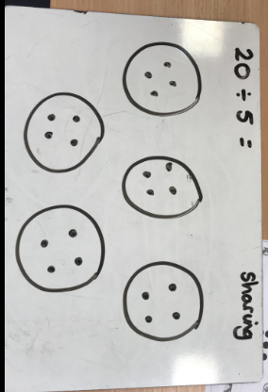  Show sharing in ‘chunks’  5 5 5 5  20 divided by 5 equals 4 rows. | 20 ÷ 5 = 4
Grouping  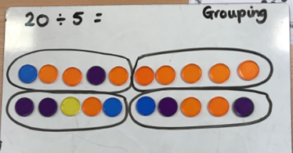  How many groups of 5 make 20?  20 has been divided into 4 equal groups of 5. | 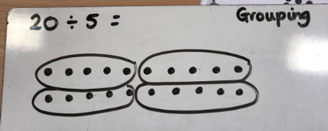  5 5 5 5 | 20 ÷ 5 = 4
Link division to multiplication by creating an array and finding 4 realted number sentences.  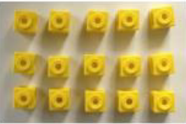  15 ÷ 3 = |  | 15 ÷ 3 = 5  15 ÷ 5 = 3  3 x 5 = 15  5 x 3 = 15
Year 3 Objectives:
Pupils should be taught to:
- recall and use division facts for the 3, 4 and 8 multiplication tables
- write and calculate mathematical statements for division using the multiplication tables that they know, including for two-digit numbers times one-digit numbers, using mental and progressing to formal written methods
- solve problems, including missing number problems, involving division, including positive integer scaling problems and correspondence problems in which n objects are connected to m objects.
Concrete | Pictorial | Abstract
Pupils to understand that division is not commutative. Use the relationship of multiplication facts to calculate. | See above for examples of grouping and sharing using concrete and pictorial resources, and exploring the relatrionship between multiplication and division.
Pupils begin to explore formal written method, at first with no remainders.  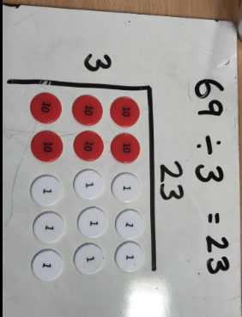 | 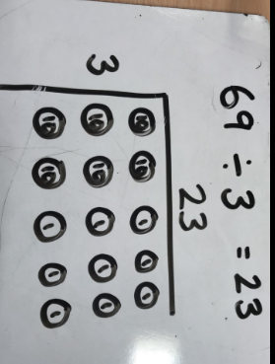 | 69 ÷ 3 = 23  2 3  3 6 9
Progress onto division with remainders, within the ones column so there is no need to exchange when subtracting using a more formal method.  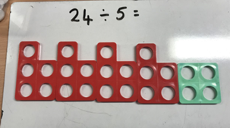  or  50 ÷ 3 =  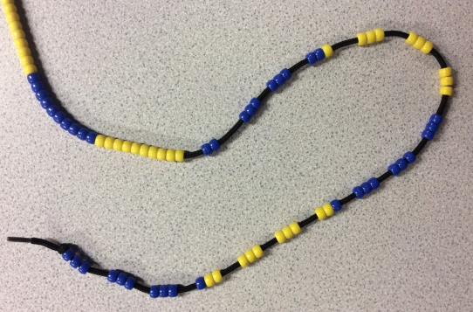 | 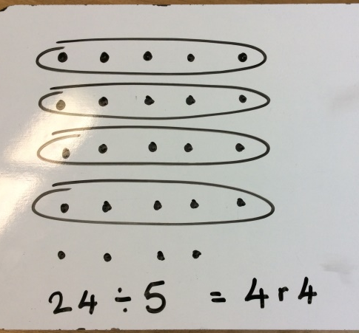 | 24 ÷ 5 = 4 r4  1 6 r2  3 5 0  - 3 0 (10x)  2 0  - 1 8 (6x)  2  (No exchange required for the subtraction)
Year 4 Objectives:
Pupils should be taught to:
- recall multiplication and division facts for multiplication tables up to 12 × 12
- use place value, known and derived facts to divide mentally, including dividing by 1
- solve problems involving dividing a two digit, then three-digit number by one-digit number using a formal layout
Concrete | Pictorial | Abstract
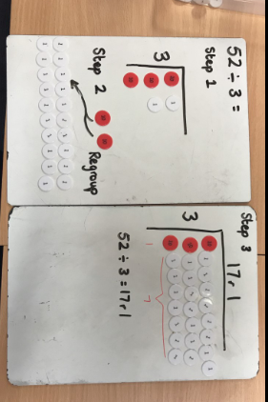  As above and developing written method with the need to exchange for 2 digit numbers divided by 1 digit. | 52 ÷ 3 = 17 r1  10 x 3 7 x 3 r1  0 30 51 52  (30) (21) | 1 7 r1  3 5 2  - 3 0 (10x)  2 2  - 2 1 (7x)  1
Progress onto division of 3 digit by 1 digit |  | 1 3 1 r3  4 5 2 7  - 4 0 0 (100x)  1 2 7  - 1 2 0 (30x)  7  - 4 (1x)  3
Year 5 Objectives:
Pupils should be taught to:
- identify multiples and factors, including finding all factor pairs of a number, common factors of two numbers, know and use the vocabulary of prime numbers and establish whether a number up to 100 is prime
- divide numbers mentally drawing upon known facts
- divide numbers up to 4 digits by a one-digit number using the formal written method of short division and interpret remainders appropriately for the context
- divide whole numbers and those involving decimals by 10, 100 and 1000
Concrete | Pictorial | Abstract
Use concrete and pictorial strategies as shown above if pupils require continued support with their understanding.
Divide 4 digit numbers by 1 digit using a short division and where appropriate, begin to interpret remainers as fractions.  Pupils begin to look at and discuss decimals in relation to money. |  | Pupils supported with multiplication where appropriate by writing the times table at the side of their work.  1 3 1 5 r3  4 5 ¹2 6 ²3  Working towards  1 3 1 5 ¾  4 5 ¹2 6 ²3  Pupils encouraged to simplify the remaining fraction where possible.  1 3 1 5. 7 5  4 5 ¹2 6 ²3. ³0 ²0
Year 6 Objectives:
Pupils should be taught to:
- divide numbers up to 4 digits by a two-digit whole number using the formal written method of long division, and interpret remainders as whole number remainders, fractions, or by rounding, as appropriate for the context
- divide numbers up to 4 digits by a two-digit number using the formal written method of short division where appropriate, interpreting remainders according to the context

Concrete | Pictorial | Abstract
Pupils use long division to calculate 3 or 4 digit numbers by 2 digit numbers.  Progress to interpreting the remainder as a decimal, where appropriate within the context of the problem. |  | The multiplication table to be recorded next to the question.  14  28  42  56  70  84  98  112  0 2 7 7/14  1 4 3 8 0  - 2 8  1 0 5  - 9 8  0 7  -  27 7/14 = 27 ½ = 27.5  15 30 45 60 75 90 105 120 0 3 5 0 . 4  1 5 5 2 5 6 . 0  - 4 5  7 5  - 7 5  0 0 6 . 0  - 6 . 0  0 . 0

